Rounded-π Probe Pairs and Perturbational Neutrality
  - An exploratory mathematical note based on recent development history
Prepared for | Project working notes
Scope | Definitions, edge cases, decimal-bracket analysis, and symbolic interpretation

Abstract
This note organizes a recent chain of ideas around rounded decimal probes of π, a perturbed trigonometric ratio family, and a proposed notion of perturbational neutrality. The lower and upper decimal probes π_m^- and π_m^+ are defined as a narrowing bracket around π, and several elementary results are recorded: bracket width, convergence, the criterion for deciding whether π is closer to the lower or upper probe, the first upper-lean event at m = 3, and later fine-scale upper propagation at m = 6 and m = 7. The ratio family N_(n,σ) is then rewritten in a cleaner sign-branch form, and the edge cases n = 1 and n = 0 are interpreted as a reduced harmonic regime and a singular oscillatory boundary respectively. A final section distinguishes literal arithmetic from a symbolic reading in which a lower/upper pair behaves as a two-part bracket rather than a standard binary counter.
Note on tone. This is written as an exploratory scientific document. Proven claims in the note are elementary consequences of the definitions; interpretive terms such as balance, forward propagation, and symbolic decomposition are stated explicitly as proposed terminology.

1. Decimal probe pairs for π
Define the lower and upper decimal probes of π at precision m by
π_m^- = floor(10^m π) / 10^m, π_m^+ = ceil(10^m π) / 10^m.
For irrational π, these probes satisfy π_m^- < π < π_m^+ for every finite m. They may therefore be viewed as an ordered probe pair that approaches π from below and above.
Examples.
m = 0: π_0^- = 3, π_0^+ = 4
m = 1: π_1^- = 3.1, π_1^+ = 3.2
m = 2: π_2^- = 3.14, π_2^+ = 3.15
m = 3: π_3^- = 3.141, π_3^+ = 3.142
Proposition 1.
The bracket width is exactly 10^-m:
π_m^+ - π_m^- = 10^-m.
Proof sketch. Since ceil(10^m π) = floor(10^m π) + 1 for irrational π, division by 10^m gives the result.
Proposition 2.
Both probe sequences converge to π as m tends to infinity.
π_m^- → π, π_m^+ → π as m → ∞.
This makes the pair useful as a finite-resolution bracket whose width is known exactly at every stage.
Figure 1 shows the bracket pair converging toward π as m increases.
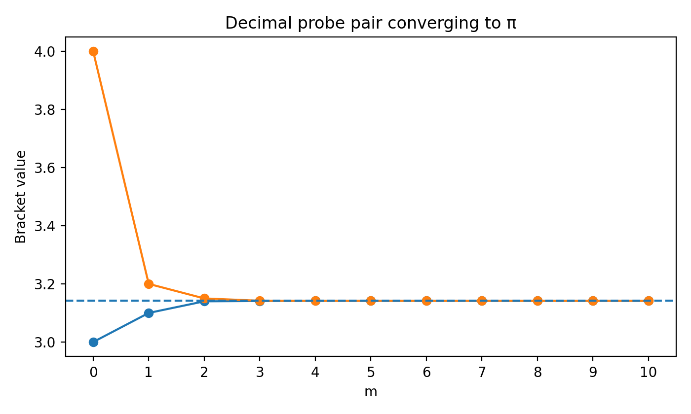
Figure 1. Lower and upper decimal probes converging to π.

2. Leaning, near-balance, and forward propagation
Define the lower and upper probe distances
d_m^- = π - π_m^-, d_m^+ = π_m^+ - π.
Then d_m^- + d_m^+ = 10^-m. Exact finite balance would require d_m^- = d_m^+, but this cannot happen for irrational π. Accordingly, balance is best treated as a near-balance notion rather than an exact equality.
A convenient signed leaning quantity is
L_m = d_m^+ - d_m^-.
If L_m > 0, π is closer to the lower probe; if L_m < 0, π is closer to the upper probe. The first upper-lean event is the first m for which L_m < 0.
Proposition 3.
The first upper-lean event occurs at m = 3.
Reason. The fractional parts of 10^m π for m = 0, 1, 2 are 0.141..., 0.415..., and 0.159..., all below one half, whereas the fractional part of 1000π is 0.592..., above one half.
π_3^- = 3.141, π_3^+ = 3.142,
π - π_3^- ≈ 0.000592653..., π_3^+ - π ≈ 0.000407346....
A near-balance magnitude can be defined by
Δ_m = |d_m^- - d_m^+| = |L_m|.
Smaller Δ_m means closer to halfway within the bracket. This is useful because exact balance never occurs, yet different precisions can still be compared.
Using this language, m = 6 is naturally described as a fine-scale upper turn, while m = 7 is both an upper confirmation and a more balanced bracket than m = 6.
Δ_6 ≈ 3.0718 × 10^-7, Δ_7 ≈ 7.1796 × 10^-9.
One possible operational definition is the following: an upper propagation event begins at m when π is closer to π_m^+ and remains closer to π_(m+1)^+ at the next precision. Under this definition, an early propagated upper event occurs at m = 3, while the later fine-scale propagated upper event occurs at m = 6 and is confirmed at m = 7.
Table 1 records the first eleven probe levels.
m | π_m^- | π_m^+ | d_m^- | d_m^+ | Closer
0 | 3 | 4 | 0.142 | 0.858 | lower
1 | 3.1 | 3.2 | 0.0416 | 0.0584 | lower
2 | 3.14 | 3.15 | 0.00159 | 0.00841 | lower
3 | 3.141 | 3.142 | 0.000592654 | 0.000407346 | upper
4 | 3.1415 | 3.1416 | 9.26536e-05 | 7.34641e-06 | upper
5 | 3.14159 | 3.14160 | 2.65359e-06 | 7.34641e-06 | lower
6 | 3.141592 | 3.141593 | 6.5359e-07 | 3.4641e-07 | upper
7 | 3.1415926 | 3.1415927 | 5.35898e-08 | 4.64102e-08 | upper
8 | 3.14159265 | 3.14159266 | 3.58979e-09 | 6.41021e-09 | lower
9 | 3.141592653 | 3.141592654 | 5.89793e-10 | 4.10207e-10 | upper
10 | 3.1415926535 | 3.1415926536 | 8.97931e-11 | 1.02069e-11 | upper
Table 1. Probe values, distances, and leaning for m = 0 to 10.
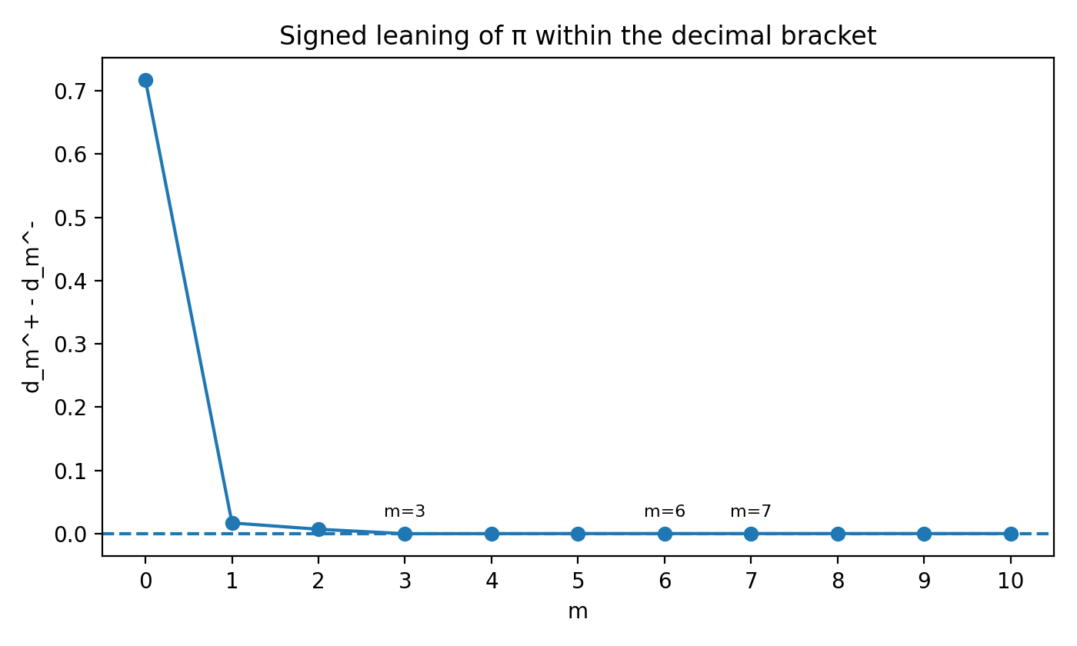
Figure 2. Signed leaning L_m = d_m^+ - d_m^-; negative values indicate an upper lean.

3. A perturbed trigonometric ratio family
The central exploratory family considered in the recent development history is
N_n(x) = (sin(x^n) + ε_1) / (sin(x^(n-1)) + ε_2), n ≥ 2.
Without perturbation, the core ratio sin(x^n) / sin(x^(n-1)) is odd wherever it is defined. With nonzero ε_1 or ε_2, that exact parity is generally broken, suggesting the phrase perturbational neutrality for a function that departs from pure odd or even symmetry while still retaining a recognizable symmetric core as the perturbations tend to zero.
A useful sign-branch form is
N_(n,σ)(x) = (sin(x^n) + ε_1) / (σ sin(x^(n-1)) + ε_2), σ ∈ {+1, -1}.
This notation subsumes the earlier expressions with factors (-1)^(2n) and (-1)^(2n+1), because for integer n those factors collapse to +1 and -1 respectively. The branch parameter σ therefore records denominator orientation directly, without redundant notation.
Combining the branch parameter with the rounded-π probe pair gives the discrete probe family
N_(n,σ)^(±,m) = (sin((π_m^±)^n) + ε_1) / (σ sin((π_m^±)^(n-1)) + ε_2).
This provides four immediate structural controls: precision m, lower/upper choice ±, order n, and branch orientation σ.

4. Edge cases n = 1 and n = 0
The boundary values n = 1 and n = 0 change the character of the family and therefore deserve separate interpretation.

Case n = 1.
N_1(x) = (sin(x) + ε_1) / (sin(1) + ε_2), x ≠ 0.
Apart from the removable issue at x = 0 arising from x^0, the denominator becomes constant and the ratio collapses to a shifted and scaled sine wave. This is best described as a reduced harmonic regime: the two-level interaction between x^n and x^(n-1) disappears.

Case n = 0.
N_0(x) = (sin(1) + ε_1) / (sin(1/x) + ε_2), x ≠ 0.
Here the numerator is essentially constant while the denominator oscillates infinitely rapidly as x tends to zero. The function typically has no limit at zero, and if |ε_2| ≤ 1 the denominator vanishes on infinitely many sequences approaching zero. This is therefore a singular oscillatory boundary rather than a mild continuation of the n ≥ 1 regime.
A useful summary is
n ≥ 2: interactive ratio regime
n = 1: reduced harmonic regime
n = 0: singular oscillatory boundary

5. Symbolic interpretation of lower and upper pairing
The expression 2 = π^- + π^+ is not a literal arithmetic identity for the decimal probes defined above. Indeed, π_m^- + π_m^+ is always approximately 2π rather than 2. Nevertheless, the expression can still be meaningful as a symbolic statement if the plus sign is read as pairing or bracketing rather than numerical addition.
Under that symbolic reading, a lower and an upper probe form a two-part decomposition around a central quantity:
π_m^- < π < π_m^+.
The pair then behaves like a bracketing unit rather than a scalar sum. In this language, '2' can be interpreted as a structural two-partness: one lower slot and one upper slot. This is consistent with the preference that '2 = 1 + 1 only' in the symbolic theory, even though it differs from the usual machine interpretation in which a 2-bit register encodes four distinct states.
For computational purposes, the usual binary interpretation remains useful. For symbolic purposes, however, the bracketing interpretation emphasizes duality, opposition, and enclosure rather than state count.

6. Appendix: computational reach of m by register size
If m is stored as a single unsigned b-bit integer in the standard computational sense, then the maximum directly representable value is
m_max = 2^b - 1.
Table 2 lists the resulting upper bounds for common word sizes.
Bit size | Maximum unsigned m
4 | 15
8 | 255
16 | 65535
32 | 4294967295
64 | 18446744073709551615
128 | 340282366920938463463374607431768211455
256 | 115792089237316195423570985008687907853269984665640564039457584007913129639935
Table 2. Standard unsigned storage limits for m.

Conclusion
The rounded-π probe construction provides a crisp mathematical core for the recent equation thread: it supplies a lower/upper decimal bracket with exactly known width, a clean criterion for deciding probe leaning, and a natural language for discussing near-balance and propagation. Coupled with the perturbed ratio family N_(n,σ), it also produces a compact exploratory framework in which decimal precision, branch orientation, perturbation, and exponent order can all be varied explicitly. The note therefore serves as a stable write-up of the current development history while leaving room for future extensions, such as alternative constants, signed-power continuations in n, or computational experiments with probe trajectories.

